**MODULE 1**

**Q. What is SDLC ?**

* It is a series of steps or phases that provide the model of development.
* It is the life cycle management for the piece of software or application.

**Q. What is software testing?**

* It is a process of used to identify the correctness, completness & the quality of the developed computer software.

**Q. What is Agile Methodology?**

* Agile methodology is a combination of Iteration & Incremental model.
* In agile methodology the software is divided in to small incremental builds, this builds are provided in iteration. It simply means that the big project is divided in to small chunks.
* In Agile Methodology, all the team member works simultenoulsy in each iteration on different areas.
* Each iteration last about four weeks
* At the end of the iteration, the workign product is displayed to the customer or the important statke holder & is released to the market. After releasing the product, the feedbacks are checked.
* if any changes or alteration are needed then it is done & is released again.

**Q. what is SRS ?**

* SRS (Software Required Specification) is a complete discription of an application which is to be developed.
* it involves use case diagram which describes the interaction, user will have with the softwre application.

**Q. What is OOPS ?**

* Object oriented programme is a way of writing the programme in organized way.
* Objects are like a black box where data are hidden.

**Q. Write basic concept of OOPS ?**

* Class
* Object
* Inheritence

Polymorphism- Over ridding

Over loading

* Encapsulation
* Abstraction

**Q. What is Object?**

Object gives the permission to access the functionality of class.

**Q. What is class?**

* Class is a collection of data member & member function.

**Q. What is encapsulation?**

* Encapsulation is a process of wrapping a data in a single unit to secure it from outside world.

**Q. What is Inheritence?**

* Inheritence means making a class from an existing class, deriving the attribute of some other class.

**Q. What is polymorphism?**

* Polymorphism means "having many forms" i.e., one name multiple forms.
* There are two types of polymorphism

1. over riding= same name of funciton with same parameter but defination will be different.
2. over loading= same function but different parameter.

***Q. Draw a use case on onlin book shopping.***

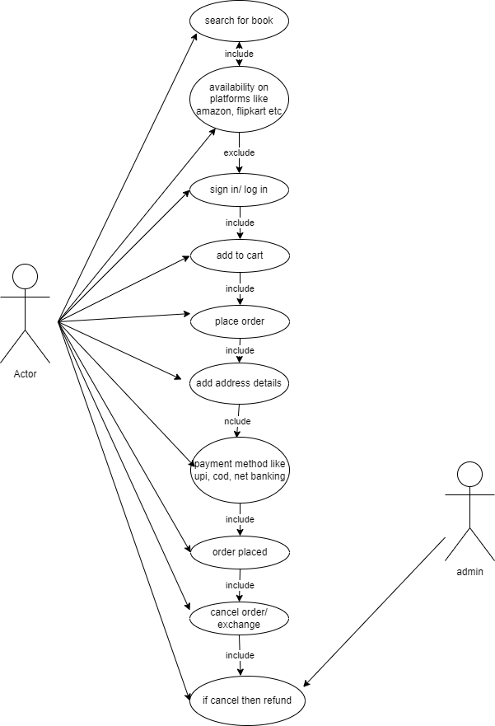

***Q. Draw usercase on online bill payment system (paytm).***

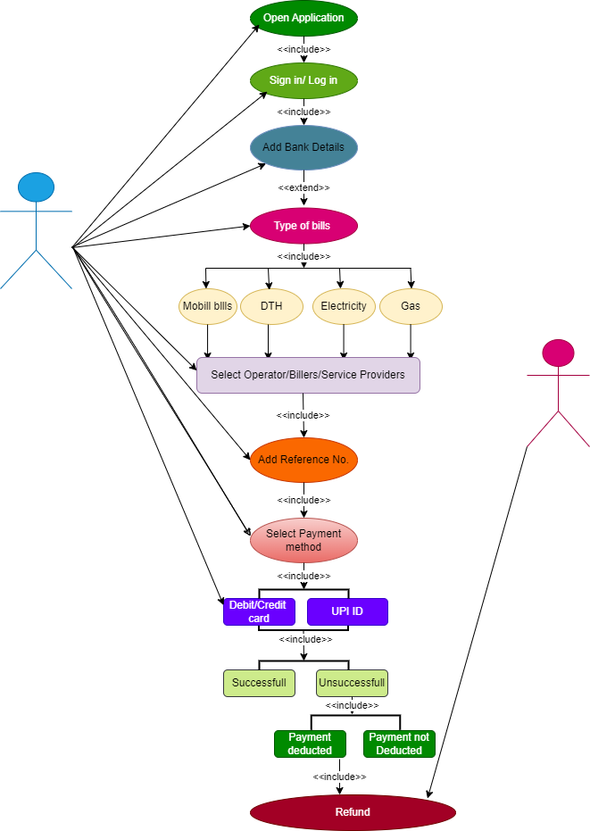

**Q. write SDLC phases with basic intoduction.**

* SDLC simply means Software Development Life Cycle.
* Phases of SDLC are.

1. **Gathering or collection of requirement**- In this each and single need or requirement of the software like operation, where will the system deploy, end user, duration, duration flexibality, improvement, is collected from the customers, stake holder, CEO's. etc.
2. **Planning:-** in this phase, basically the programming language, environment, algorithms, platforms, data structure etc in short application architecture is established. Beside this, what are the risk/cost/time for completion of the project is also discussed. In short what we actually need for the project is seen in planning phase.
3. **Design:-** As the word itself decribes, in this phase the design of the software like, implementation plan, layout, icons, fonts, background images etc are done.
4. **Implementation:-** In implementation phase, the team buildes the components either from scratch or by composition.
5. **Testing:-** in this phase, the testing of the product is done, the defect report are reported & get fixed & retesting of the product is done untill it fullfills the actual requirment.
6. **Deployment:-** The ongoing project becames actual product & is ready for the release.
7. **Maintenance:-** the maintenance phase is the phase which comes after the deployment of the software in the field.

Corrective Maintenance:- identifying & repairing defects.

Adaptive Maintenance:- adapting the existing solution to the new platforms

Prefective Maintenance:- implementing the new requirement.

**Q. Explain phases of Waterfall model.**

1. **Gathering or collection of requirement**- In this each and single need or requirement of the software like operation, where will the system deploy, end user, duration, duration flexibality, improvement, is collected from the customers, stake holder, CEO's. etc.
2. **Analysis/Planning:-** in this phase, basically the programming language, environment, algorithms, platforms, data structure etc in short application architecture is established. Beside this, what are the risk/cost/time for completion of the project is also discussed. In short what we actually need for the project is seen in planning phase.
3. **Design:-** As the word itself decribes, in this phase the design of the software like, implementation plan, layout, icons, fonts, background images etc are done.
4. **Implementation:-** In implementation phase, the team buildes the components either from scratch or by composition.
5. **Testing:-** in this phase, the testing of the product is done, the defect report are reported & get fixed & retesting of the product is done untill it fullfills the actual requirment.
6. **Deployment:-** The ongoing project becames actual product & is deployed i.e., ready for the release.
7. **Maintenance:-** the maintenance phase is the phase which comes after the deployment of the software in the field.

**Q. Write phases of spiral model**

* **Planning:-** Determination of objectives, alternatives & constrains
* **Risk Analysis:-** Analysis of alternatives & identification/ resolution of risk
* **Engineering:-** Development of the "Next Level Project"
* **Customer Evaluation:-** Assesment of the result of engineering.

**Q. Write agile manifesto principles.**

* Agile model believes that every project needs to be handled differently & the existing method needs to be changes to best which suits the project requirement.
* In agile, the tasks are divided into small time frame to deliver specific features for a release.
* Agile thought process had started early in the software development & started becoming popular with the time due to its flexibility & adaptibility.

**Q. Explain working methodology of agile method & write its pros & cons.**

* It is the combination of iterative & incremental mode.
* It divides the software into small incremental builds, this builds are provided in iteration, that means the big project are divided into small chunks.
* Each iteration last about four weeks.
* Each iteration involves all the team member to work simultenously on areas like planning, requirement analysis, design, coding, unit testing & accepetance testing.
* at the end of the iteration the working product is displayed to the customers or the important stake holders & is released to the markets.
* After the release, the feedbacks are checked of the deployed software.
* If any enhancement is needed in the project, then it is done & is rereleased.

**Pros-** Frequent Delivery

Face to Face communication with the customer

Less time

Adaptability

**Cons-** Less documentation

Maintenance

QUE : DRAW THE USE CASE ON ONLINE SHOPPING PRODUCT USING COD

ANS : 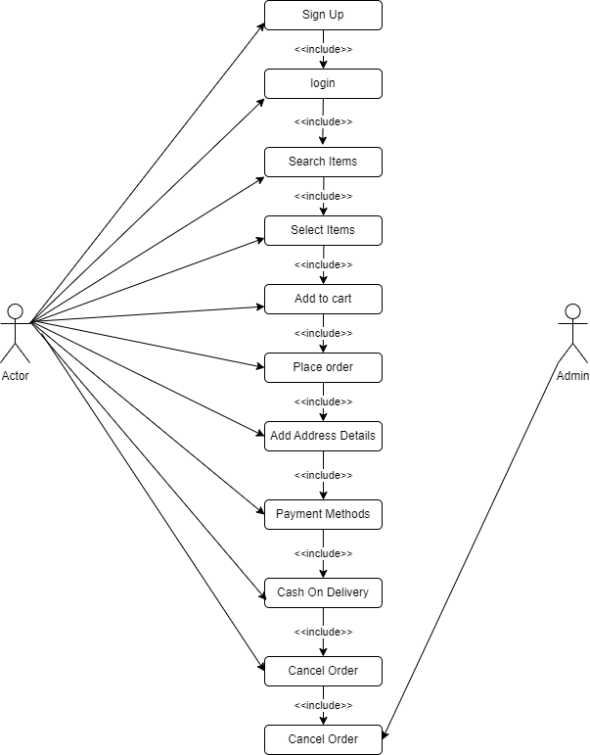

**QUE : DRAW USE CASE ONLINE SHOPPING PRODUCT USING PAYMENT GATEWAY?**

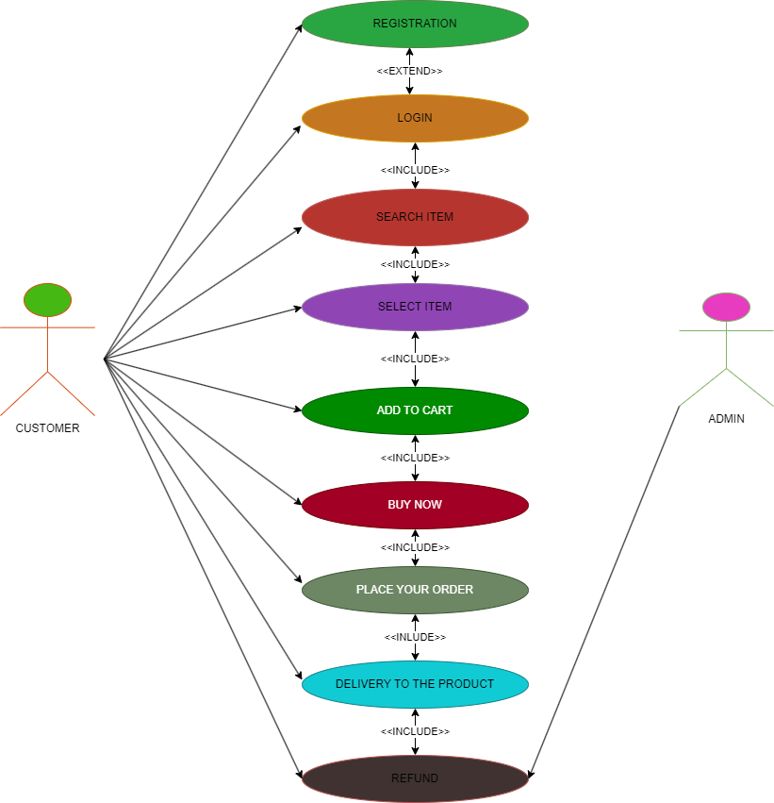

** THE END**